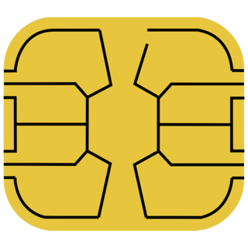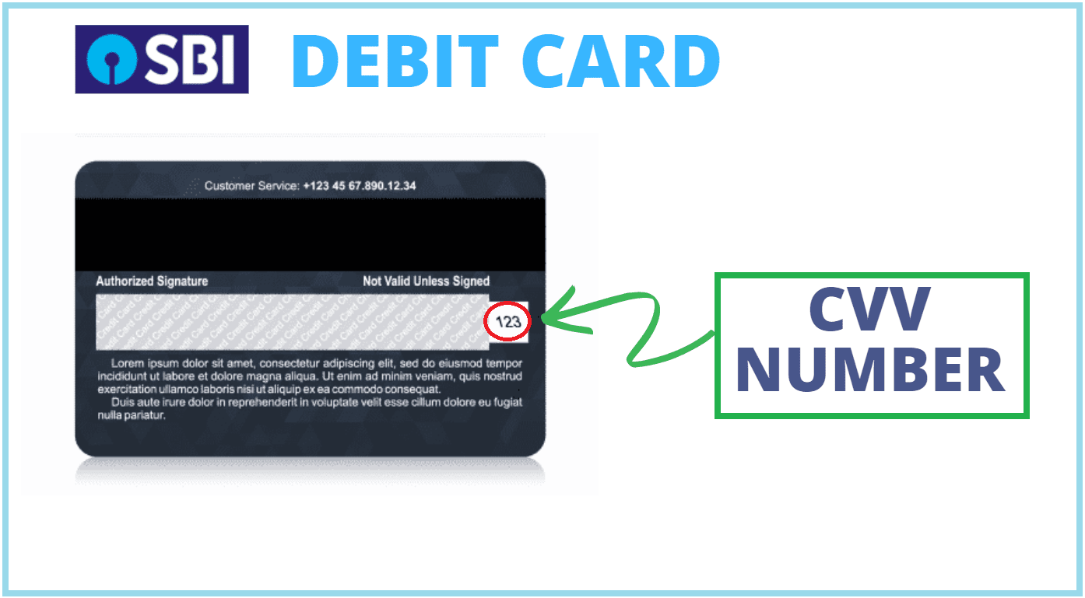

**6754 4563 5764 6547**

Loren ipsum Dolor sit ametup,b sascgyc gdgycfxuu frgesxgyeg dsracvj kamvcd kavarui kjhytfvc .

**DEBIT CARD**

544

544

SACHIN **02\26**

SBISBI

VISA

6754 4563 5764 6547

Lol